1. WE HAD TO ADD {TO STRING} TO THE STUDENT CLASS

THERE WAS NO NEED FOR TWO CONSTRUCTORS FOR ADDRESS CLASS

ENUMERATION VS ITERATOR

|  |  |
| --- | --- |
| Using *Enumeration*, you can only traverse the collection. You can’t do any modifications to collection while traversing it. | Using *Iterator*, you can remove an element of the collection while traversing it. |
| *Enumeration* is introduced in JDK 1.0 | *Iterator* is introduced from JDK 1.2 |
| *Enumeration* is used to traverse the legacy classes like *Vector*, *Stack* and *HashTable*. | *Iterator* is used to iterate most of the classes in the collection framework like *ArrayList*, *HashSet*, *HashMap*, *LinkedList* etc. |
| Methods : *hasMoreElements()*and *nextElement()* | Methods : *hasNext()*, *next()* and *remove()* |
| *Enumeration* is fail-safe in nature. | *Iterator* is fail-fast in nature. |
| *Enumeration* is not safe and secured due to it’s fail-safe nature. | *Iterator*is safer and secured than *Enumeration*. |

2.

If an entry is removed via **Set.remove()** while an iteration is being done, you will get a ConcurrentModificationException. WE HAVE TO SAVE THE VARIABLE IN ANOTHER DATA STRUCTURE AND THEN MODIFY IT

3. JVM

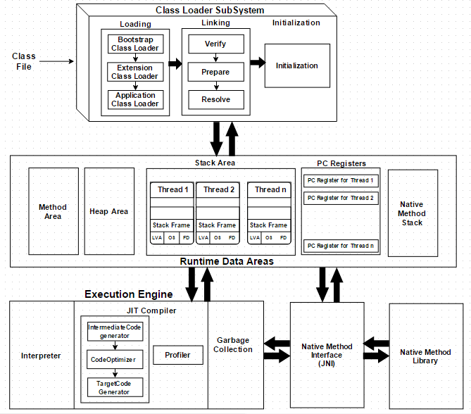

**HOT SPOT**

HotSpot, released as Java HotSpot Performance Engine, is a Java virtual machine for desktop and server computers, maintained and distributed by Oracle Corporation. It features improved performance via methods such as just-in-time compilation and adaptive optimization

4.